InPlace

Student Confirmation Guide

Rhode Island College

Copyright 2016 Quantum Information Technology Pty Ltd. All rights reserved.

Information in this document is subject to change without notice. The software described in this document is furnished under a license agreement or nondisclosure agreement. The software may be used or copied only in accordance with the terms of those agreements. No part of this publication may be reproduced, stored in a retrieval system, or transmitted in any form or any means electronic or mechanical, including photocopying and recording for any purpose other than the purchaser's personal use without the written permission of Quantum Information Technology Pty Ltd.

Quantum Information Technology Pty Ltd
www.Inplacesoftware.com
info@inplacesoftware.com

Student Confirmation Process
- Log into InPlace: https://ric-us.inplacesoftware.com/
- In your to do list you will see an item that requires your attention: Field Confirmation – Internship Status
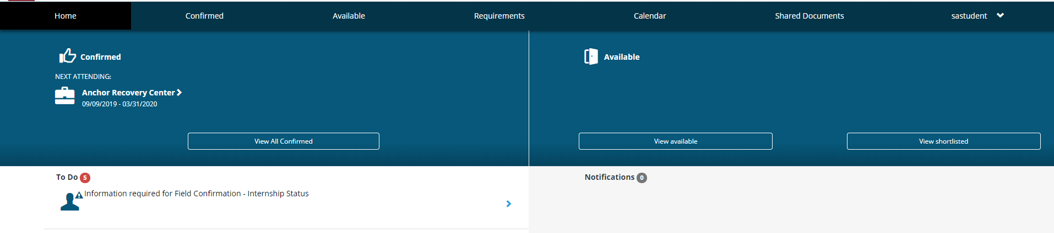
- Click on this to do item.
- Fill out your Interview Status
  - Internship Accepted
  - Internship Offered
  - Internship Accepted with Changes
    - If Option C is chosen, complete the Field Updates field detailing what information is changing, i.e. Field Instructor, location, etc. If you are changing your MSW Supervisor’s information, please provide name, email address and phone number of the supervisor.
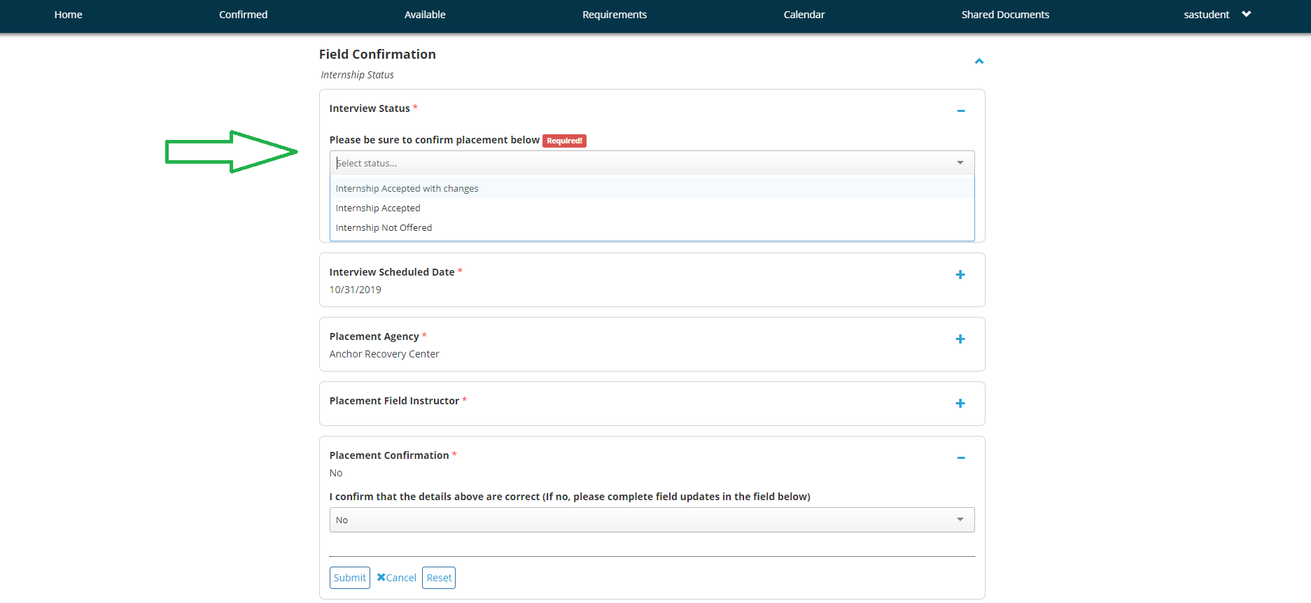
- Once items are shown to be correct, update Placement Confirmation field to Yes.
- Updating this field will trigger email notification of the Field Confirmation form to you, your Faculty Liaison, and your Field Instructor
